

**Digital Logic Lab Assignment 20 & 21**

* To construct a 2-bit Synchronous counter
* To construct a 4-bit Synchronous counter
* To construct a BCD Synchronous counter

**Submitted By**

Gaurav Chaulagain

Year I / SEM I

017BSCIT014

**Submitted To**

Signature Remarks

Er. Saugat Sigdel

Lecturer, Dept. of Computer Science

**OBJECTIVE :**

**To Construct synchronous counter**

**THEORY:**

Synchronous Counters are so called because the clock input of all the individual flip-flops within the counter are all clocked together at the same time by the same clock signal

**2-Bit Synchronous Counter:**

**Circuit Diagram:**

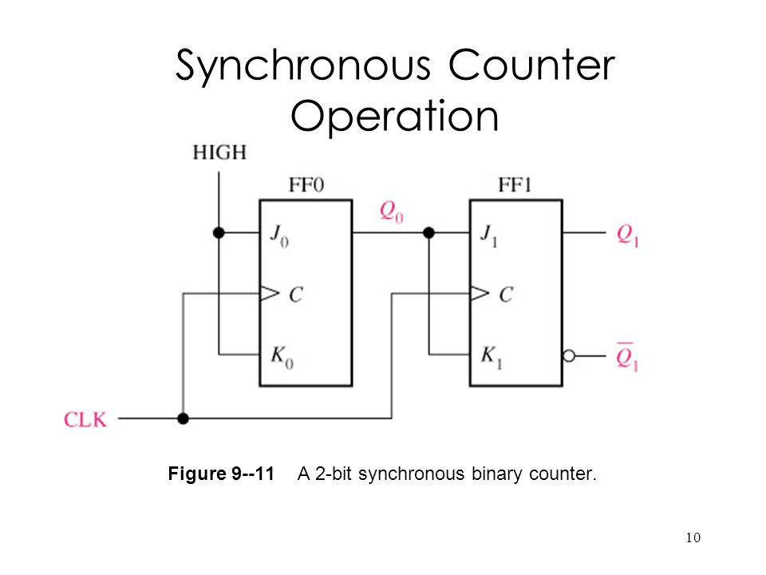

**Observation:**

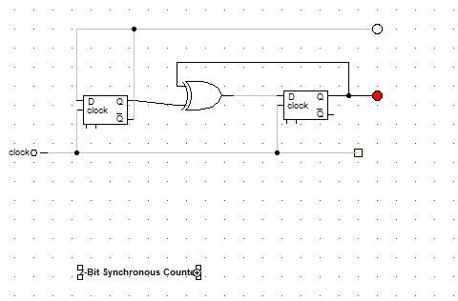

**4-Bit Synchronous Counter:**

**Circuit diagram:**

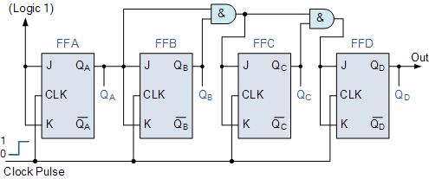

**Observation:**

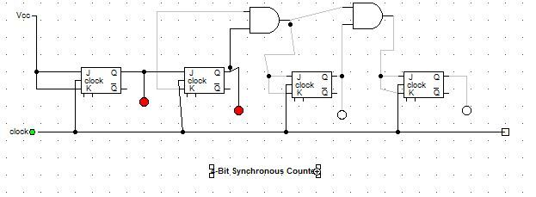

**BCD Asynchronous Counter:**

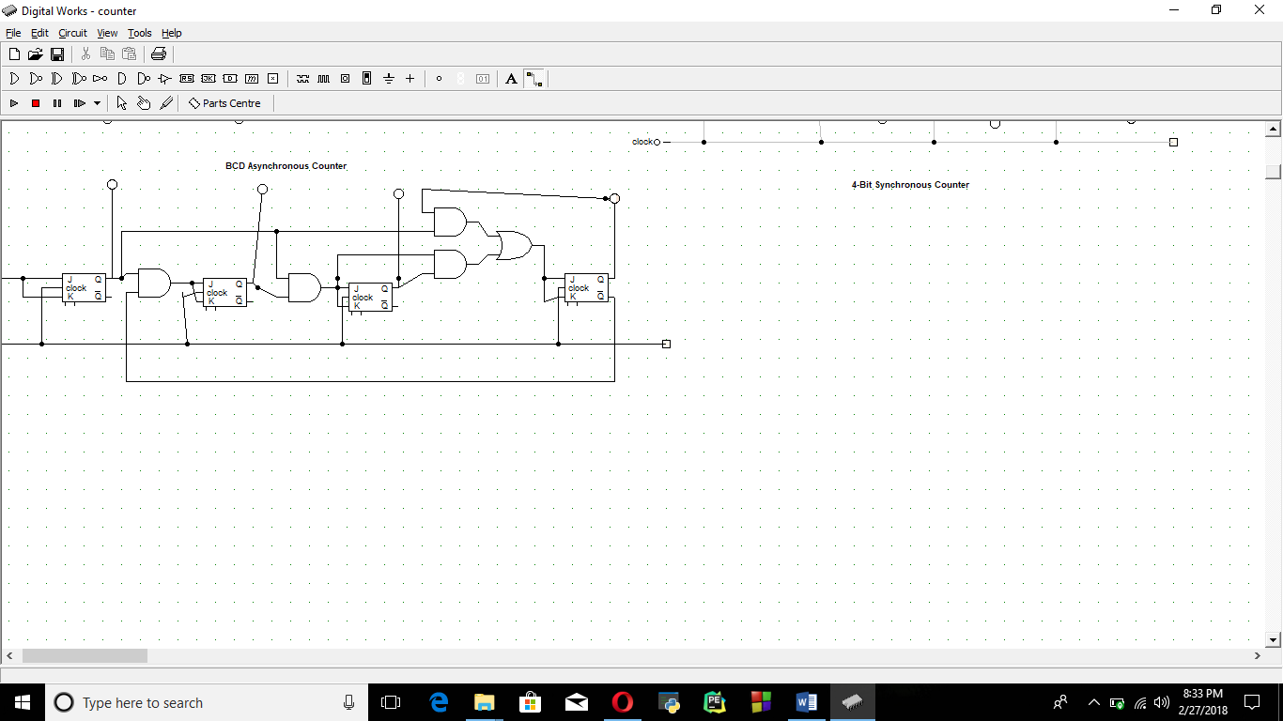

**Conclusion:**

Thus, the Synchronous counters were constructed.